**[http://www.labour.ap.gov.in/](http://www.singlewindow.jk.gov.in/)**

**STANDARD OPERATING PROCEDURE (SOP)**

Registration under The Trade Unions Act, 1926

**Department of Labour and Employment**

Government of Andhra Pradesh

**Name of Service**

Registration under The Trade Unions Act, 1926

**Name of Department**

Department of Labour and Employment, GoAP

**Policy/Government Order**

The Trade Unions Act, 1926

**Documents Checklist**

|  |  |  |  |
| --- | --- | --- | --- |
| # | Document name | Type | Mandatory |
| 1 | Constitution of Union- Particulars showing the provision made in the rules of section 6 of Indian Trade  Unions Act (Schedule II) (two copies) | PDF | Yes |
| 2 | Resolution of General Body (two copies) | Pdf | Yes |
| 3 | List of Members - Particulars required by section 5-1 c of Indian Trade Unions Act, 1926 (List of Officers-Schedule I)-  Two Copies | PDF | Yes |
| 4 | Bank Account of Union | PDF | Yes |
| 5 | Register of Expenditure | PDF | Yes |
| 6 | Copy of identity Cards of Members | PDF | Yes |
| 7 | Photographs/Address/Telephone No's of Executive Body | PDF/JPEG | Yes |
| 8 | Inventory of Assets and Liabilities of Union- Particulars required by section 5(2) of Indian Trade Unions Act 1926 (Statement of Assets and Liabilities-  Schedule III) | PDF | Yes |
| 9 | Office of Union (Photograph) | JPEG/JPG | Yes |
| 10 | Rubber Stamp of President/General Secretary | PDF | Yes |
| 11 | Cash Book, Minute Book, and Membership Register | PDF/JPG/JPEG | Yes |
| 12 | On-spot verification report along-with recommendation for registration | JPEG | Yes |

|  |  |  |  |
| --- | --- | --- | --- |
| **#** | **Document name** | **Type** | **Mandatory** |
| **13** | **Certificate by the verifying Officer to the effect that no other identical Union**  **exists in the areas** | PDF | Yes |
| **14** | **Rent deed** | PDF | Yes |

# Schedule 1 - List of Officers (Provisions through online platform)

|  |  |  |  |  |
| --- | --- | --- | --- | --- |
| **Title** | **Name** | **Age** | **Address** | **Occupation** |
|  |  |  |  |  |
|  |  |  |  |  |

*Note: - Enter in this Schedule the names of all members of the executive of the Union showing in column 1 the names of any posts held by them (e.g. President, Secretary, Treasurer, etc.) in addition to their offices as members of the executive.*

# Schedule II - Reference to Rules (Provisions through online platform)

**The numbers of the rules-making provision for the several matters detailed in column 1 are given in column 2 below:**

|  |  |
| --- | --- |
| **Matter** | **Number of Rules** |
| Name of the Union |  |
| The whole of the objects for which the union has been established |  |
| The whole of the purpose for which the general funds of the union shall be applicable |  |
| The maintenance of a list of Members |  |
| The facilities provided for the inspection of the list of Members by officers & Members |  |
| The Admission of Ordinary Members |  |
| The Admission of Honorary or Temporary Members |  |
| The conditions under which the members  are entitled to benefits assured by the rules |  |
| The condition under which forfeitures can be imposed or raised |  |
| The manner in which the rates shall be  amended or rescinded |  |
| The manner in which the members of the Executive and other Officers of the Union |  |

|  |  |
| --- | --- |
| **Matter** | **Number of Rules** |
| shall be appointed and removed |  |
| The safe custody of the Funds |  |
| The Annual Audit of the Accounts |  |
| The facilities for the inspection of Accounts Book by Officers and Members |  |
| The manner in which the Union may be dissolved |  |

**SCHEDULE III - STATEMENT OF LIABILITIES AND ASSETS ON THE DAY**

**OF… 20**

**(Provisions through online platform)**

**(This need not be filled in if the Union came into existence less than one year before the date of application for registration.)**

|  |  |  |  |
| --- | --- | --- | --- |
| **Liabilities** | **Rs.P** | **Assets** | **Rs.P** |
| Amount of General fund Amount of political fund Loans…. from  Other liabilities (to be Specified) |  | CASH  In hands of Treasurer In hands of Secretary In hands of-  In the Bank In the Bank  Securities as per list below Unpaid subscription due Loans to-  Immovable property Goods and furniture  Other assets (to be specified) |  |
| **Total Liabilities** |  |  |  |

**List of Securities (Provisions through online platform)**

**Applicant Process Flow**

|  |  |  |  |
| --- | --- | --- | --- |
| **Particulars** | **Nominal** | **Market value** | **In hands of** |
| 1 |  |  |  |
| 2 |  |  |  |
| 3 |  |  |  |
| 4 |  |  |  |

* ***State here whether the authority was given by a resolution of a general meeting of the Union, if not, in what other way it was given***

# Fees

**Rs. 500** per Union at the time of making an application before the Registrar for registration of Trade Union.

# Process Flow: Registration under Trade Union Act, 1926

**Registration/Project Creation on SW and CAF details requires for**

**the first time SW users only**

Submitted to department for verification and approval/clarifies, if query raised by Dept

Select Service from Service Clearance

Make the Payment

Verifies/ Uploaded documents and forms

Enter the Application for Registration Under Trade Union Act Form Details

Upload Documents in Document Manager

Add CAF to create CAF ID and fills Q logic and to apply service -first time regn on SW

Applicant create a project -first time regn on SW

Approves



Applicant Register/ Login on SW-OTP Verified

Submits

Clarification

Raise Query to the Applicant

**Timeline-30 Days**

Reverts with Recommendations within 2 Working Days

I

II

Level – (Labour Commissioner) 2 + days

Forwards if found Eligible ( 2 Days) ,

Verifies/ Raise Query to level 3 if needed and make decision Approval and issue certificate

or Rejects)

Reverts with Remarks

Level – (Assistant Labour Commissioner )

7 days

Scrutinise/ Verifies,

and revert with remarks

Raises Query- within 7 days Timeline stops

Level – (Deputy Labour Commissioner )

2+2 days Scrutinise/ Forwards, revert with remarks

Level –

(Trade Union Clerk Concerned) 7+3 Days

1. Verifies Form and Documents and if needed raise Query (7

Days),

1. Forwards with Remarks for Approval(3 Days)

Department/ Admin Process flow

After Approval- Applicant receives the status and can view/ download the certificate through login

# Procedure for the application for Registration under Trade Union Act, 1926

* 1. Applicant registers himself/herself on single window system [http://www.singlewindow.jk.gov.in.](http://www.singlewindow.jk.gov.in./) If, already registered on the portal then login with the registered user id and password
  2. Applicants get the registration information on registered email id and registered mobile number.
  3. Your first step is to create a Project (a Project can be your new or existing Business/Industry).
  4. Once a Project is created, you can fill the Common Application Form for the Project where all the common details required for the project are filled.
  5. Once CAF Id is created, from all the available Forms, click on the Form/Registration you want to apply for.
  6. Before filling the forms, you will be given instructions about the documents required to submit along with the form. You need to upload these documents before filling the form.
  7. Now you can apply for Application for Registration under Trade Union Act.
  8. Make payment of necessary application processing fees online using your debit card/ credit card/ net banking facility
  9. Filled application form will be submitted to Concerned Trade Union Clerk
  10. After online receipt of application form for issuance of Registration under Trade Union Act with all the necessary documents mentioned above, the Concerned Trade Union Clerk shall scrutinize the application along with uploaded documents
  11. In case of deficiency Trade Union Clerk shall report the deficiency to the applicant within 7 working days.
  12. If there is no deficiency the Trade Union Clerk shall recommend the application to Labour Commissioner with remarks, who in turn will send the application to Deputy Labour Commissioner within 2 working days.
  13. Deputy Labour Commissioner will send the Application to Verifying Officer (Assistant Labour Commissioner) for verification within 2 working days.
  14. Verifying Officer (Assistant Labour Commissioner) will verify the Application and will forward the case with his recommendations for Registration or otherwise to Deputy Labour Commissioner within 7 Working Days.
  15. Deputy Labour Commissioner will forward the case with his remarks to the office of Labour Commissioner within 2 days.
  16. The concerned clerk upon examining the file, fee and other relevant Documents shall forward the case to Labour Commissioner (Registrar Trade Union) with his remarks within 3 working days.
  17. If the Labour Commissioner is satisfied that the case is fit for registration, he shall approve the same and certificate of registration shall be generated automatically. In case the Labour Commissioner is not satisfied, he shall send back the case to the applicant or concerned Assistant Labour Commissioner for rectification within 8 working days.
  18. The certificate can be downloaded from the applicant login.

# Form Fields:

|  |  |  |  |  |
| --- | --- | --- | --- | --- |
| **#** | **Section** | **Caption Name** | **Type of Field** | **Mandatory (Yes/ No)** |
| **1.** |  | Name of Trade Union | Alpha/ numeric | Yes |
| **2.** | Trade Union | Address of Head Office | Alpha/ numeric | Yes |
| **3.** | Details | City | Alpha | Yes |
| **4.** |  | District | Alpha/ Dropdown | Yes |
| **5.** |  | Pin code: * | Numeric | Yes |
| **6.** |  | Contact Number | Numeric | Yes |
| **7.** |  | Trade union came into existence | Calendar | Yes |
| **8.** |  | Type of Union | Dropdown | Yes |
| **9.** | Documents | Constitution of Union- Particulars showing the provision made in the rules of section 6 of Indian  Trade Unions Act (Schedule II) (two copies) | Upload Option/ Dropdown | Yes |
| **10.** |  | Resolution of General Body (two copies) | Upload Option/ Dropdown | Yes |
| **11.** |  | List of Members - Particulars required by section 5-1 c of Indian Trade Unions Act, 1926 (List of Officers-Schedule I)-Two  Copies | Upload Option/ Dropdown | Yes |
| **12.** |  | Bank Account of Union | Upload Option/ Dropdown | Yes |
| **13.** |  | Non-Involvement Certificate from Police | Upload Option/ Dropdown | Yes |
| **14.** |  | Department/Passport Copy | Upload Option/ Dropdown | Yes |
| **15.** |  | Copy of identity Cards of Members | Upload Option/ Dropdown | Yes |
| **16.** |  | Photographs/Address/Tele phone No's of Executive Body | Upload Option/ Dropdown | Yes |

|  |  |  |  |  |
| --- | --- | --- | --- | --- |
| **#** | **Section** | **Caption Name** | **Type of Field** | **Mandatory (Yes/ No)** |
| **17.** |  | Inventory of Assets and Liabilities of Union- Particulars required by section 5(2) of Indian Trade Unions Act 1926 (Statement of Assets and  Liabilities-Schedule III) | Upload Option/ Dropdown | Yes |
| **18.** |  | Office of Union (Photograph) | Upload Option/ Dropdown | Yes |
| **19.** |  | Rubber Stamp of  President/General Secretary | Upload Option/ Dropdown | Yes |
| **20.** |  | Photocopy of Cash Book, Minute Book, and Membership Register | Upload Option/ Dropdown | Yes |
| **21.** |  | On-spot verification report along-with recommendation for registration | Upload Option/ Dropdown | Yes |
| **22.** |  | Certificate by the verifying Officer to the effect that no other identical Union  exists in the areas | Upload Option/ Dropdown | Yes |
| **23.** |  | Rent Deed | Upload Option/ Dropdown | Yes |
| **24.** |  | Additional attachment 1  to 4 | Upload Option/ Dropdown | Yes |

**Do’s and Don’ts Do’s**

1. Ensure that relevant document as mentioned in the Standard Operating Procedure is uploaded at appropriate place.
2. Reply at the earliest or in 7 days to the clarification raised by the Department Officer for the Application.
3. Raise grievances on Single Window, if Approval is not granted within specified timeline.
4. Download your Approval certificate/ License/Registration etc. from the portal only.

# Don’ts

1. There is no need to visit the Dept. for approval or any clarification.
2. Don’t submit any physical hard copy of document to the Dept.
3. Don’t upload irrelevant documents in the Application which is not

mentioned in the Document Checklist

# References:

1. The Trade Union Act, 1926 ([https://www.indiacode.nic.in/bitstream/123456789/2386/1/AAA1926tr 16.pdf](https://www.indiacode.nic.in/bitstream/123456789/2386/1/AAA1926tr__16.pdf))

# Appendix

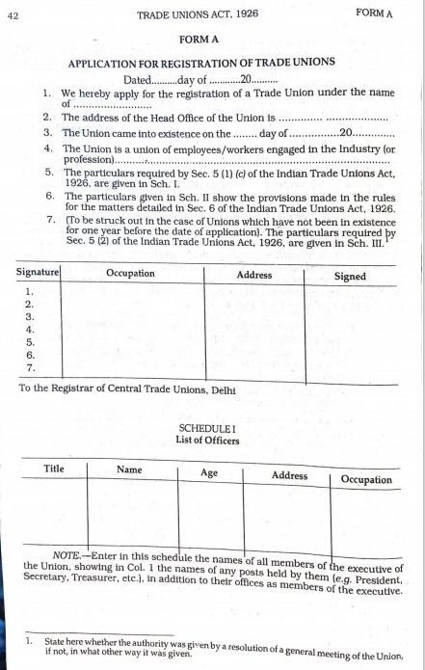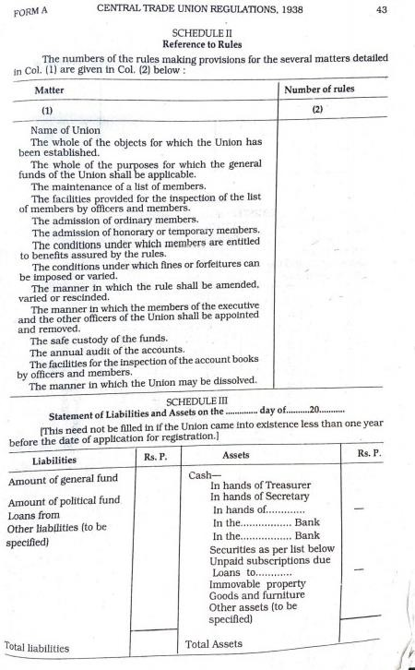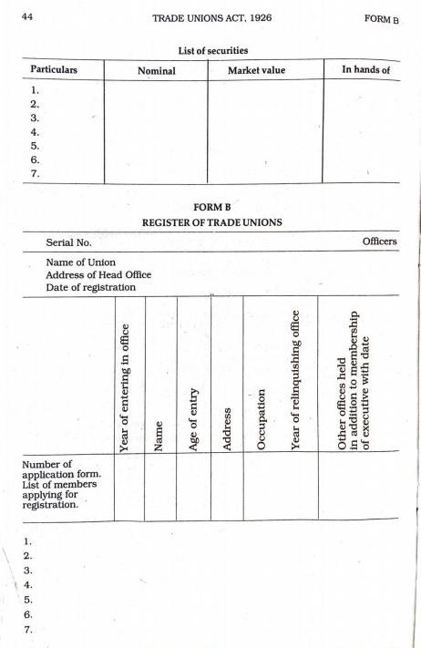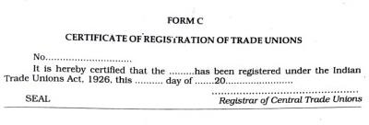

**System Generated Certificate would be provisioned and with Approval No, applicant unit name and date**